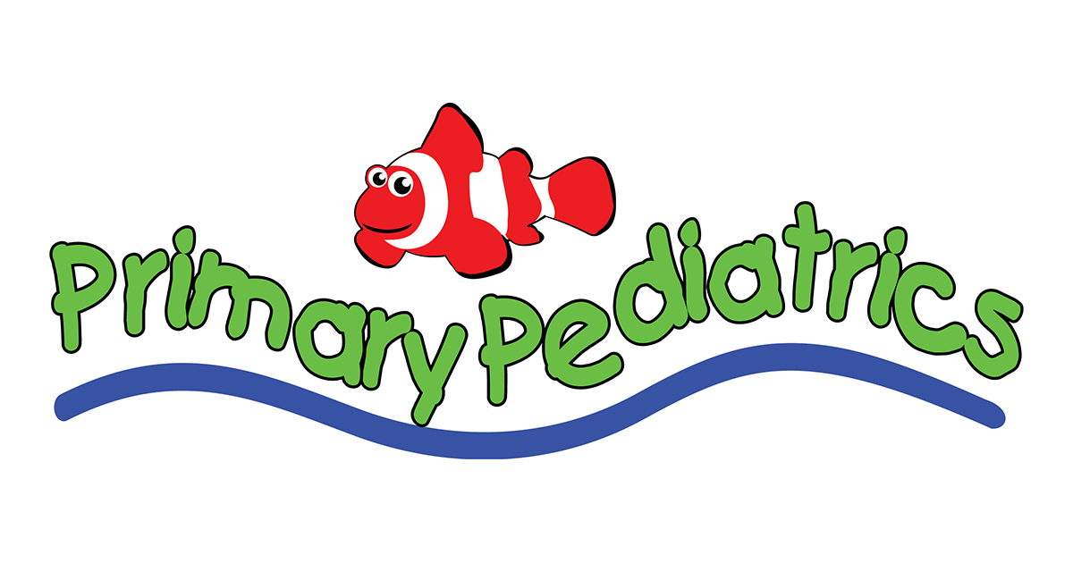
ACCEPTED INSURANCE PLANS
Primary Pediatrics accepts the following insurance plans. However, this list is not comprehensive. If you do not see your plan on this list, please contact our office at (478) 741-3007 for support.

AETNA | - HEALTH SMART PPO
- AETNA POS | HUMANA
- AETNA PPO | - HUMAN POS
ASSURANT HEALTH | - HUMAN PPO
BLUE CROSS BLUE SHIELD OF GEORGIA | TRICARE
- BLUE CROSS PPO | MEDICAID
- BLUE CROSS EPO | - AMERIGROUP
- BLUE CHOICE OPTION POS | - CARESOURCE
- BLUE OPEN ACCESS POS | - GEORGIA HEALTH PARTNERSHIP
- BCBS FEDERAL | - PEACH STATE
- BLUE CHOICE HMO | MULTIPLAN
CIGNA | - MULTIPLAN PPO
- CIGNA HMO | - PHCS NETWORK POS
- CIGNA POS | - PHCS NEWORK PPO
- CIGNA PPO | NATIONAL ASSOCIATION OF LETTER CARRIERS (NALC)
CORE MANAGEMENT RESOURCES | MEDCOST (SECURE HEALTH)
COVENTRY HEALTH CARE | TRICARE
- COVENTRY HEALTH CARE POS | UNITED HEALTH CARE
- COVENTRY HEALTH CARE PPO | UMR
FIRST HEALTH (COVENTRY HEALTH CARE) | UNITED HEALTH CARE POS
- FIRST HEALTH (COVENTRY HEALTH CARE) POS | UNITED HEALTH CARE PPO
- FIRST HEALTH (COVENTRY HEALTH CARE) PPO | WEB TPA
HEALTH SMART
- HEALTH SMART POS

